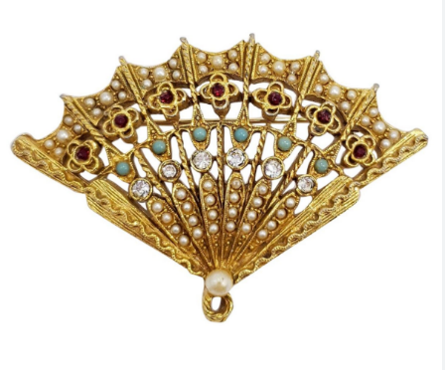
NCRL Spring Lace Day
April 29, 2023
Seymour Center, 2551 Homestead Rd Chapel Hill, NC
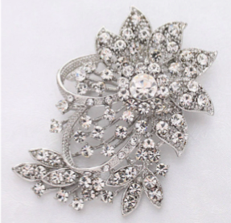
Theme: Broaches and Bling
Schedule:
Time | Activity
9:00 am | Sign – In, Tables Open
9:00 am – 3:00 pm | Vending, Lacemaker’s Alley
10:00am – 12:00 pm | Classes
12:00 pm – 1:30 pm | Lunch
1:30 pm – 2:30 pm | Continuation of Classes
2:30 pm – 3:00 pm | Speaker Presentation
3:00 pm – 3:30 pm | General Meeting and Door Prizes

A delicious buffet lunch is being provided by the Piedmont Lacers.

Classes

Note: Kit fees are paid directly to the instructor

Tatted Butterfly by Gretchen Miller
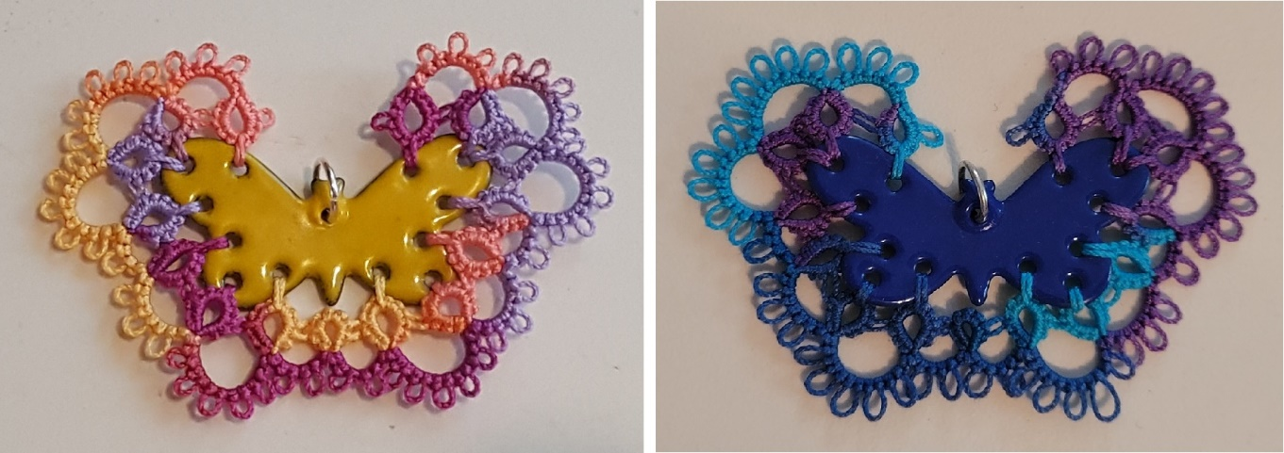

Tatted Edged Butterfly Pendant. Kit cost $15; Class limit 10.

Bobbin Lace Broach by Tonya Little

Bobbin Lace Broach. Kit cost $12; Class limit 12.

Felt Hedgehog Pin Cushion by Vicki Lamb

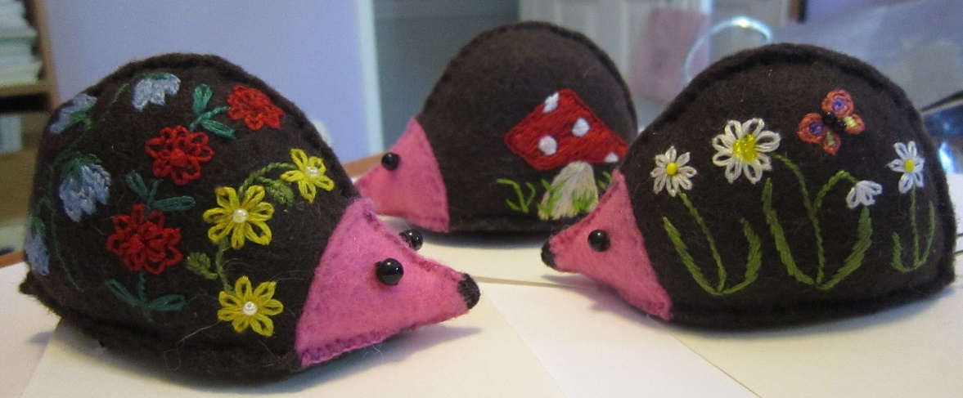

Felt Hedgehog Pin Cushion. Kit cost $8; Class limit 10.

Lace Display
Want to volunteer to help?
Go to https://www.signupgenius.com/go/30e0f4ba8ac2faaf49-2023
Please bring any of the following items to display at Lace Day:
Lace you finished recently, antique lace, antique bobbins, old prickings, antique pillows, unusual pillows.
Modern laces such as wire lace, colorful laces, jewelry, holiday decorations, folk costumes, etc.

Lace Maker’s Alley
Sellers: Do you have lace supplies you no longer need? Sell them in the Lace Maker’s Alley. Label the items with your name and a price. You will be responsible for the sale of your items.
Buyers: Remember to find the seller and pay for your finds!

Door Prizes
We will be giving out fun door prizes after the business meeting. Is there anything in your stash that is new or gently used that you would like to donate? Just bring the item to Lace Day.

Vending
Van Sciver Bobbin Lace. A broad assortment of bobbins, and needle lace books, threads, and supplies. Contact Holly early to place special orders.
http://www.vansciverbobbinlace.com

Commemorative Bobbins and Shuttles by Chris Parsons
Featuring a hedgehog and dogwood flowers. DEADLINE for ordering; Jan. 31, 2023
Name: ___________________________________________________________________________________________

Email: ___________________________________________________________________________________________

Phone: _____________________________ Food allergies: ________________________________________________
A buffet lunch will be provided by the Piedmont Lacemakers.
NCRL Spring Lace Day April 29, 2023 Registration
First 30 registrants will receive a goodie bag!

Commemorative Bobbin (DEADLINE JAN. 31, 2023)
Make check out to NCRL, Mail to Liz Redford at 8004 Connestee Ct, Raleigh, NC 27612
For questions contact Vicki Lamb trephina@gmail.com
Bobbin Style | Price per bobbin | Quantity | Total
Spangled Midland | $12.50
Binche | $13.70
Long International | $13.70
Tatting Shuttle | $19.25
Grand Total
Class | 1st Choice | 2nd Choice | 3rd Choice
Tatted Butterfly
Bobbin Lace Broach
Felt Hedgehog Pin Cushion

